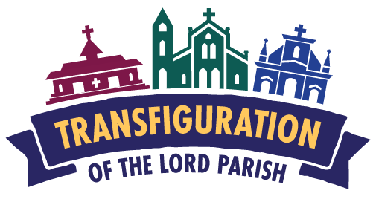
14 Park Street, North Attleborough, MA 02760
stmaryna@noozi.com + 508-695-6161 + www.saintmaryna.com

16 March 2020

Dear Fellow Parishioner of Transfiguration of the Lord Parish,

I pray that this letter finds you well during these constantly changing times. I know that there is a lot of uncertainty surrounding the Covid-19 virus. I write, not to alarm you unnecessarily, but it has been brought to my attention that a member of the parish staff had physical contact on Monday, March 9th with someone who has tested positive for the virus. This staff member did come to work the following day, hence, the entire parish staff was exposed. The entire parish staff will now need to be in quarantine until Tuesday, March 24th. Clearly, this is distressing but I am happy to say that not one of us, including the staff member who had the actual physical contact with the one who tested positive is exhibiting any flu-like symptoms.

Clearly, the Parish Office will remain closed until March 24th. In advance, I would like to apologize for any and all inconveniences this will undoubtedly cause. Since both Father Jack Schrader and I are quarantined, we will be unable to celebrate Sunday Masses the weekend of March 21/22. The provisions of Canon 1245 authorize the local pastor to dispense parishioners under his pastoral care.

Canon 1245 With due regard for the right of diocesan bishops which is mentioned in canon 87, for a just reason the diocesan bishop, the pastor in individual cases can dispense from the obligation to observe a feast day [Sunday is the Feast Day of the Lord] or a day of penance; or he can commute it to other pious works.

As I extend this dispensation to the entire Catholic Community of Transfiguration of the Lord Parish as pastor, I ask that each reading these words take some time to read the Sunday readings for the Fourth Sunday of Lent and to think about the powerful words. I am also hoping to have a YouTube link on our parish website so that you can watch my Sunday homily. Fr Jack and I want to stay connected with you and promise that each and every day we will offer Mass for our parish family.

Lastly, I do ask that you prayerfully consider continuing to financially supporting the parish so that we can continue to pay the bills that will undoubtedly arrive at the parish office. The US Postal System is still delivering…for the time being…so in advance, thank you for your support and generosity.

Please be assured of my prayers for you and your loved ones.

Love,
Fr. Rodney
Reverend Rodney Eric Thibault, J.C.L., Pastor

