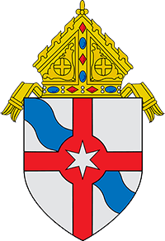

Statement of Bishop Edgar M. da Cunha, S.D.V., Suspending
the Celebration of Masses in the Fall River Diocese
March 16, 2020
Out of concern for the health and well-being of all who reside in Southeastern Massachusetts, Cape Cod and the Islands and in response to the direction of public officials, I am suspending all public Masses and other liturgical services in the Diocese of Fall River effective Tuesday, March 17, 2020 and continuing until further notice. This includes Masses of First Holy Communion and Confirmation.
At the same time, I am issuing a dispensation from the obligation to attend Mass during this time to all Catholics of the Diocese.
Exceptions are granted for the celebration of weddings and funerals, but attendance must be limited to immediate family members only, not to exceed 10 persons. Every effort must be made to follow precautions already announced in previous communications from the Diocese along with recommendations of public health officials.
I am asking that churches be open for a limited time during the day to the extent possible and at the discretion of the pastor to provide the faithful who still wish with an opportunity to visit for private prayer. Parishes should provide this information on their websites.
I strongly encourage our Catholics to pray at home and to seek out opportunities to participate in Masses available on television or online instead. Information is available on our website, www.fallriverdiocese.org.
The Mass is our central act of worship, the source and summit of our Catholic faith, and it goes without saying that this difficult decision was not made lightly. It was done after prayerful consideration of the critical health threat that now confronts us. The gravity of it demands that we take whatever action is needed, despite the hardship, for the good of the protection of all especially those who are most vulnerable at this time.
Please join me in prayer in these challenging days for all who are impacted by COVID-19 and in a special way for those who are sick and for those who work to combat the disease.
I wish to entrust all of our people especially our sick and elderly to the protection of our Blessed Mother, Our Lady of the Assumption the patroness of our Diocese, so that under her motherly care we all may persevere in faith to support one another. Let us all pray that this may come to a quick end and normalcy may be restored.

