Baptismal Preparation at Transfiguration of the Lord Parish

What is baptism, why do we baptize?

Baptism is a sacrament of initiation…a welcoming into the Church and our parish community in particular. The sacrament gives a person a new and special status as a child of God. Sometimes we get very busy with the “planning and party” aspect of this, however it is very important to remember the sacramental nature of the day.

As a sacrament of initiation, baptism welcomes the infant not just into the Roman Catholic faith, but into our Parish family at Transfiguration of the Lord Parish as well. For this reason, families who request that their infant be baptized here are asked to be active members in our parish community.
“The origin and foundation of Christian Baptism is Jesus. Before starting his public ministry, Jesus submitted himself to the baptism given by John the Baptist. The waters did not purify him; he cleansed the waters. . . . Jesus did not need to be baptized because he was totally faithful to the will of his Father and free from sin. However, he wanted to show his solidarity with human beings in order to reconcile them to the Father. By commanding his disciples to baptize all nations, he established the means by which people would die to sin – Original and actual – and begin to live a new life with God.
In Baptism, the Holy Spirit moves us to answer Christ's call to holiness. In Baptism, we are asked to walk by the light of Christ and to trust in his wisdom. We are invited to submit our hearts to Christ with ever deeper love.”
~from the United States Catholic Catechism for Adults
By Baptism we become members of the Church, the Body of Christ.

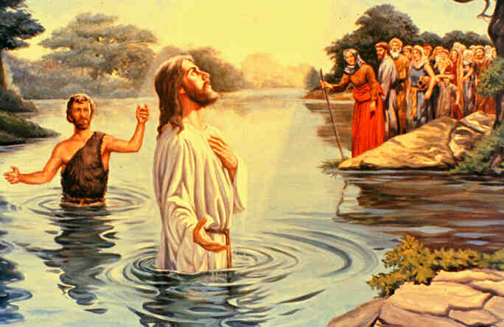

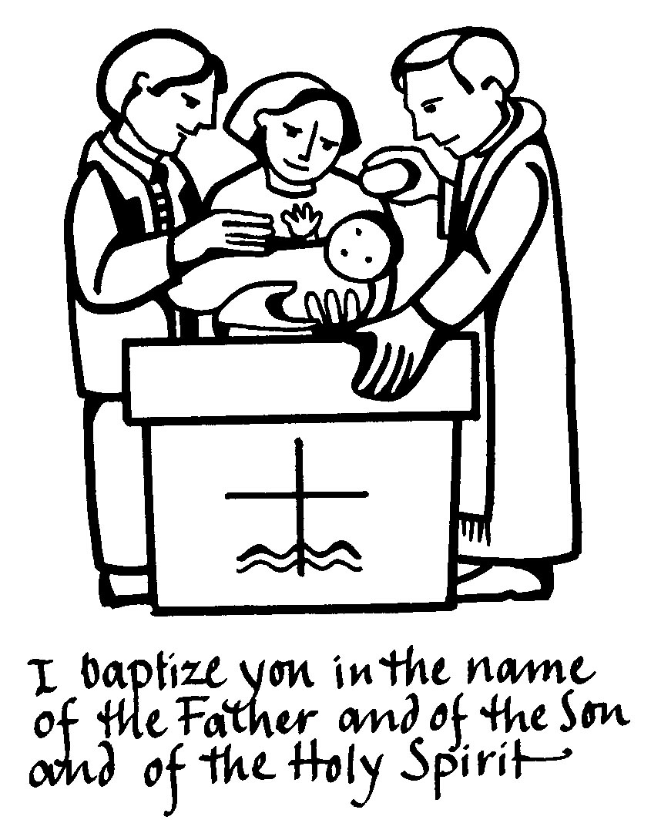

What are you asking for and promising when you have
your child baptized in the Church?

You are promising to raise your child in the Roman Catholic faith at baptism. As a witness to this faith, you will raise child in faith by practicing your faith together. You are your child’s first teacher, he or she will be watching you and learning from you, in all things. So many new routines begin when a baby is born into a family. As your baby grows you will be establishing all kinds of new family routines – mealtime, bathtime, bedtime. Faith routines are no different.

If you have been away from active participation in the Church now is a good time to make your faith and Church participation part of your new part of your routine. Begin praying with your child, bless them each night as part of your bedtime routine. At first, of course, you will be saying the prayers, but even as an infant, and maybe especially as an infant, praying the “Our Father”, “Hail Mary”, “Glory Be” and the “Prayer to our Guardian Angel” and asking for God’s blessing on your child and your family each day is a wonderful way to wind down at the end of what is often a long day. Even now, watching the Mass together via the internet is an easy way to start (you can pause if someone needs to be fed) When we are able to resume attending Mass safely, begin attending regularly and make it part of your new weekend routine. Go out after Mass, even just a cup of coffee and a munchkin….have a special family breakfast … create your own special memories and traditions. We begin our week thanking God for all that has happened in the past week, asking for His help for the week to come. As new parents, or parents of a growing family, taking some time to refocus on God’s infinite love for us and passing that on to your children is an important part of your role as parent.

St. Augustine: Sacraments are a “visible sign of an invisible reality, a visible sign of invisible grace.”

What do you need from your Godparents?

The Church asks you to choose carefully when you ask someone to be a godparent for your child. You will be asking someone to support you in your role in raising your child in the Catholic Church. There are guidelines that were provided in the first letter you received, they are included again in this packet. Please review these guidelines…but remember YOU are your child’s first teacher…your godparents role is to assist you. This is not necessarily time to “honor a friend”. Godparents represent the Christian Catholic community (the Church). For these reasons, they need to be people who believe in the teachings of the Church, have received all their sacraments and are willing to be role models of their faith. Sometimes there is someone in your life, a sibling or a close friend, who grew up in the church, but has been away for any number of reasons. People move away and have not found a new parish where they feel ready to become regular members, or their jobs may require them to work weekends, or they have just fallen out of practice in going to Church. The birth of your child, and a candid and honest discussion of faith, may be the start of your friend’s journey back to faith. Encourage them to think about whether they are willing to recommit to a regular practice of their faith and share this journey with you and your family. We are always available to have a discussion with them and welcome them back.

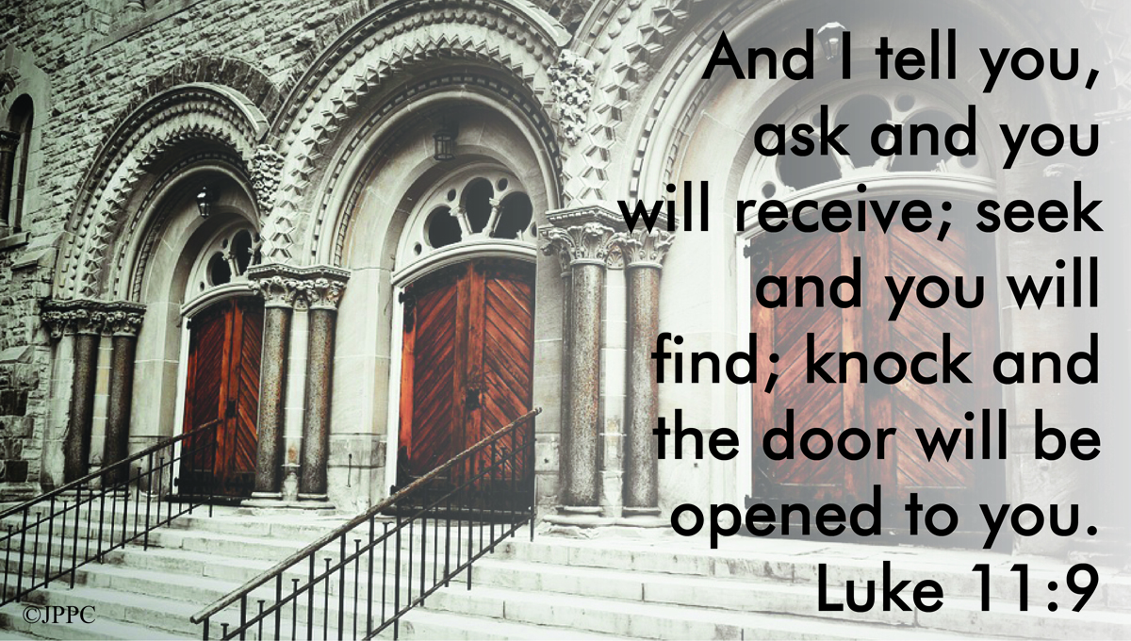

The Roman Catholic Church requirements for Godparents are as follows:

- A child must have one practicing Roman Catholic godparent in good standing with the Church.
- This Catholic godparent must be at least 16 years old and be mature enough to understand, accept and carry out the duties of a godparent.
- A godparent must have received the Sacraments of Initiation: Baptism, Eucharist and Confirmation.
- A godparent must be living an exemplary life consistent with faith and morals as taught by the Roman Catholic Church.
- A godparent must be actively practicing the faith.
- A non-Catholic, baptized Christian may be chosen as a Christian Witness, as long as one godparent is Catholic.
- If two godparents are chosen, they may not be of the same gender.
- There may be no more than two godparents.
- If both are Catholic, both must meet all the criteria above.
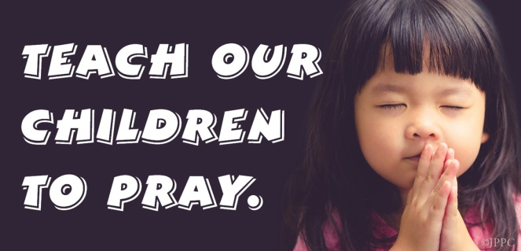

Bringing your child to church
It is never too early to start, and to start them with good “Church” habits. As they move past the bottle stage, they will learn that Mass is not a time for eating and drinking, but quiet time. Church toys… a little stuffed lamb, child Bible, quiet items only used at Church time, can be part of their “Church routine”. Some families have found it handy to have a “church time bin” in their homes. Items that are “church friendly” – small toddler bible, soft books, stuffed animal, nothing that has music or sound please. You child – or you – can grab an item or two as you head out to Mass and then put them back for next weekend when you get home.

Don’t be afraid to take baby to back and walk around if they become too fussy or upset during Mass….as they get older you can take them out as necessary. Reinforce “good” behavior…special snack or sticker chart for special activity (go to the park in the afternoon, special video…) when they have behaved well in church. Help them to learn to listen and be quiet, and share some special time in God’s house. As they get older, show them the missal, and follow along with them during the Mass. Children’s missals are available that have lots of pictures so they can follow along.

FAQ
On Baptismal Day
We have put our previous schedule of baptism on hold for now. Father will baptize one child at a time, with families keeping their total number to 24 ( not including Father). We will work with you and your family to provide a safe and holy time for your child. We will resume our former schedule when we feel it is safe for all to do so.
Other things to know
*It is a good idea to bring a towel to dry baby’s head after the water is poured on his/her head.
*Your baby will be anointed with holy oil on both the chest and head. Please make sure you leave neck open or unbutton gown or attire at the back, so you can pull down the front a little bit, for anointing.
*We provide candle and bib
* Please do not bring food and beverages into the church during the baptism.
* It is customary to make a donation to the Parish and a stipend for the presider. Typically the donation for the church ranges from $100 to $200. Either Father Jack, Father Rodney, or Deacon Joseph Regali will preside, it is nice to recognize them as well. These are free will offerings and are not fees for the sacrament. Any type of acknowledgement is gratefully accepted.

Please feel free to let me know if you have any questions. It is important for me to receive all of your completed paperwork two weeks before the baptism. This includes the godparent sponsor forms. This will give Father an opportunity to review all the information and for me to prepare the necessary certificates and paperwork.

If our godparent form is used, it must be completed and signed by the godparent and signed and the parish seal stamped on the form by their current parish. If they are currently active members of Transfiguration of the Lord Parish, they may make a notation and we will take care of it from there. The godparent should just sign the form and return it. If their parish has a form they prefer, that is absolutely fine. If you need to email me a scanned copy to move things along, that is fine. You can drop the original copies in the mail or drop them by the office as I will need them for the records.

Finally we ask that you read through all the materials sent to you regarding the Sacrament of Baptism. This includes the following:

- This introduction packet
- The Rite of Baptism explained
- The Signs and Symbols of Baptism
- The Effects of Baptism
- Prayers to Teach Your Child
- Baptism Reflection
- Acknowledgement sheet
- 10 minute baptism video https://youtu.be/pD7kE8qUz5A

Please sign, date and return the form acknowledgement sheet, indicating that you have received and reviewed this information. We appreciate you taking the time to prepare your family for this important event in your child’s life.

May you know God’s many blessings as you celebrate this special moment of faith in your family’s life. I will be happy to answer any questions and help prepare for this wonderful day.
I can be reached most easily by email at stmaryna@noozi.com

Peace & prayers,
Monica

Monica T. Forte
Administrative Assistant
Transfiguration of the Lord Parish
North Attleborough, MA

